Brick it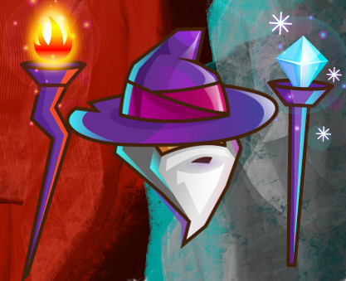

Fact sheet

Publisher:

Aleksandar Komazec

Developer:

Aleksandar Komazec

Launch Date:

3rd Q 2022

Price:

Free

Platforms:

* PC, keyboard support, controller support
* Android, user interface support

Contact:

LinkedIn: https://www.linkedin.com/in/aleksandar-komazec-489970197/

Genre

Brick it core: 2D platformer  
Additional genres: RPG, Action, Survival, Battle Royale

Game brief:

The main protagonist is a wizard with a specific type of magic (Ice, Fire, Dark, Healing ...). Main protagonist walks on the map. This map keeps many secret items that can be very powerful in terms of improving the wizard's magic. Keep in mind that these items are placed somewhere deep in the map, and the only way to reach these items is to destroy everything (Including the map bricks, yes like in Minecraft), and enemies. In addition to regular opponents, there is also a boring indestructible Soul Reaper (Pay attention, indestructible), so the only way to avoid certain death is to run as fast as possible to escape from Soul Reaper. Destroying the map bricks is a desirable way of playing the game because it provides an amount of experience to the player. Leveling system is also very important because new levels provide new spells. There is a skill tree, so the player can make a unique combination of spells). After every map, there is a boss fight.

Game modes:

* SP (Single player), only one player is included.
* COOP (Cooperative), up to x players are included. Main benefit of the mode that players can combine their spells to get something more powerful.
* PvP (Player vs Player), Instead to fight some unfriendly AI NPCs (Artificial Intelligence non playable characters), two players will fight each other.
* BTR (Battle Royale), x players will be included into fight, and the last standing one is winner

Features

Legend:

* Dev high priority Red Box Clip Art at Clker.com - vector clip art online, royalty free &amp;  public domain (Features that will be implemented first)
* Dev med priority , (Features that will be implemented second, some of these are optional)
* Dev low priority , (Features that will be implemented last, totally optional)

Base features:

* Animated playable characters



* Animated non-playable characters AI controlled



* Destroyable maps



* Collectibles (Items that power ups player’s spell)



* Basic traps



Action features:

* A lot of animated spells



* Combining spells



* Advanced Animated traps



RPG features:

* Leveling system



* Skill tree system



* Inventory system (To store collectibles, and consumables)



* Entity attributes (Health points, Spell cooldown, …)



* Quest system



* Character Dialogue



* Character creation, adding spells to created character



Online features:

* BTR (Battle Royale) mode



* PvP (Player vs Player) mode



* COOP (Cooperative) mode



* Skin shop



* RNG quick game system



Offline features:

* SP (Single player)



* COOP (Cooperative)



* PvP (Player vs Player)



Immersion features:

* Immersive graphic background effects (Such as parallax)



* Immersive camera modification effects (Such as camera shaking effects)



* Immersive set of sounds (Cast spell sounds)



Survival features:

*  Weather disasters system (Such as heat, coldness, and so on)
*  Survival consumables (Cold water against heat, campfire against coldness)

FAQ sheet

Question: What is the focus in the game?  
Answer: The focus in the game is destroying bricks using pretty versatile set of spells. Also building unique spell tree in order to get powerful spells

Question: Is the game based on Fremium or Premium model?  
Answer: This game is based on Fremium model, so in the future mini transaction skin shop will be implemented in order to provide different skins for players, and monetize itself

Question: Would it be possible to download on many platforms?  
Answer: Yes, the base target is play store on Androids, but also Steam, and others will come in story later.

Team Bio

I am nearly one man show, let’s say nearly solo developer who has two years of experience in Embedded Application programming. Started learning Gaming development pretty nearly, so started this project without a lot of experience in game development.

As I previously said, nearly one man show because there is my fiance Snežana. Her role is to review some art designs, she also helps to make some decisions, and Snežana has a role of rubber duck

Logo Artwork

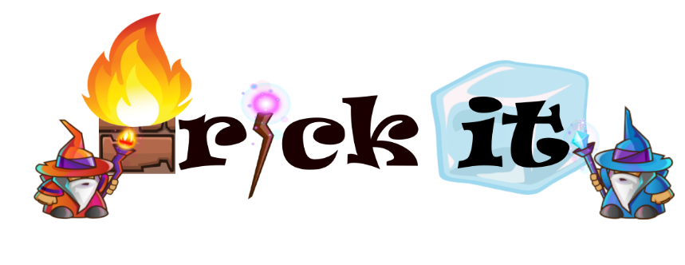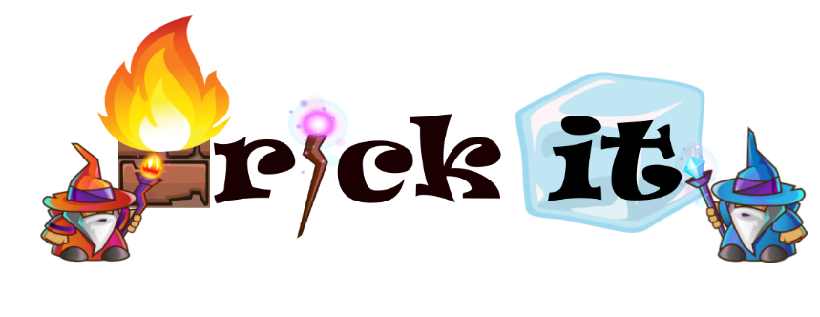

Screenshots(Placeholder)

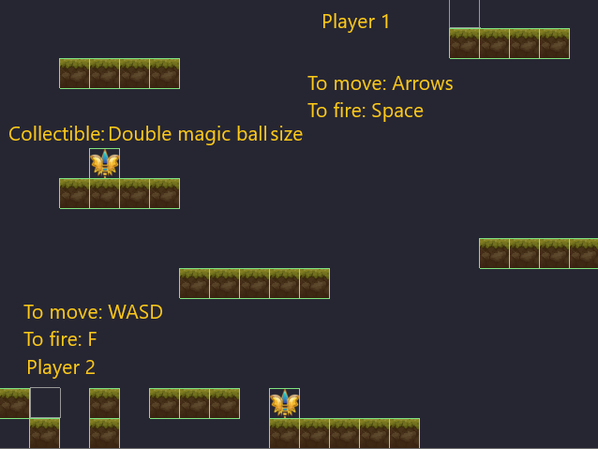

Video Demo(Placeholder)



Graphics package(demo)

Main character sprites:

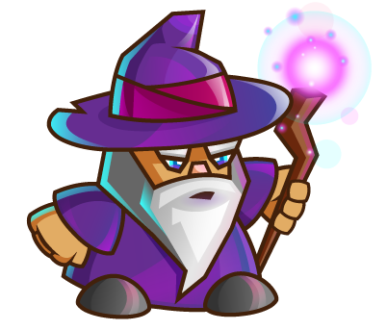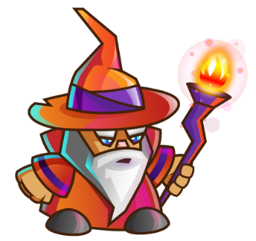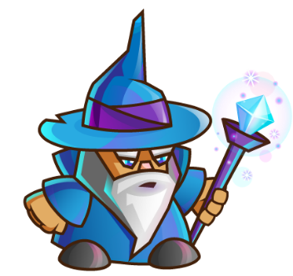

NPC sprites (Bosses):

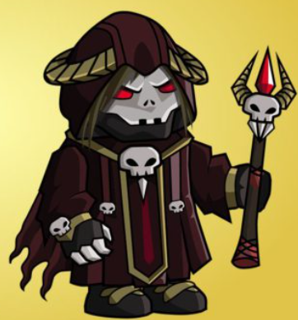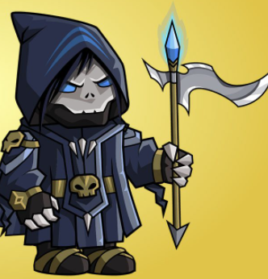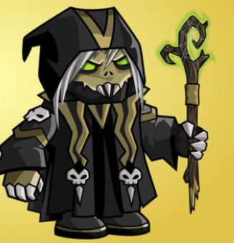

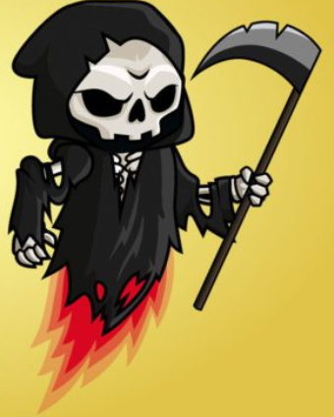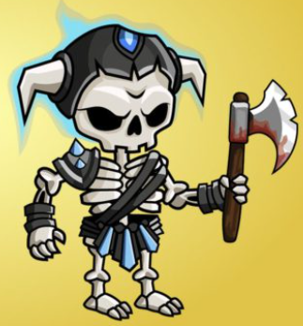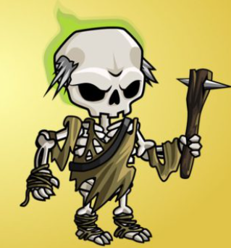

NPC sprites (Regular enemy):

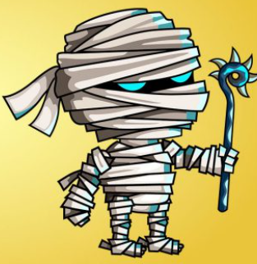 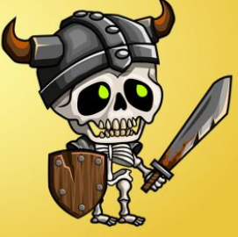 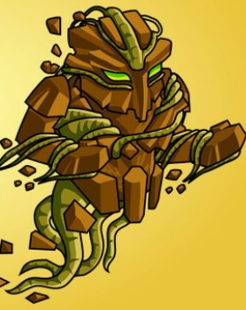

Spell effects (Just a placeholder):

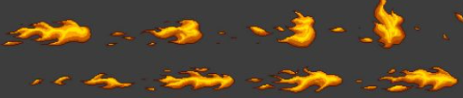

Spell icons (Just a placeholder):

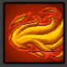 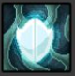 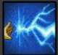

Amulet Items (Just a placeholder):

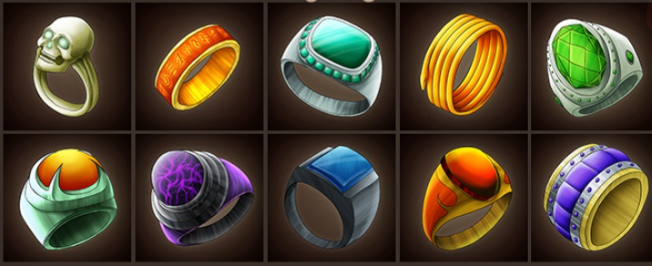

Tile Set Maps (Just a placeholder):  
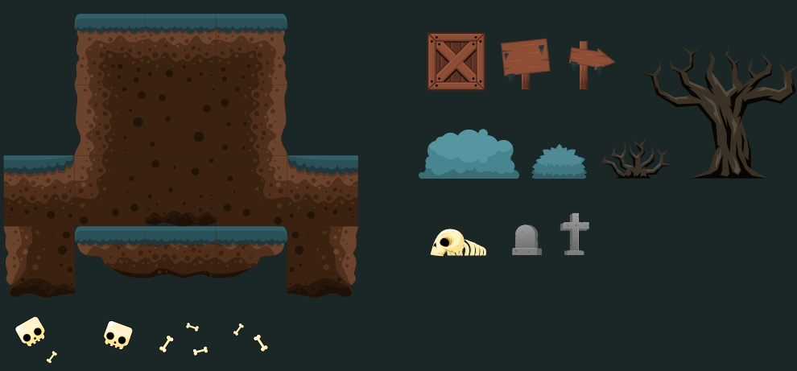 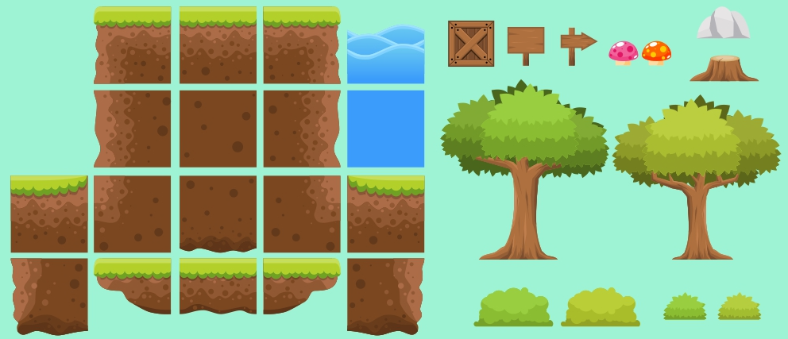 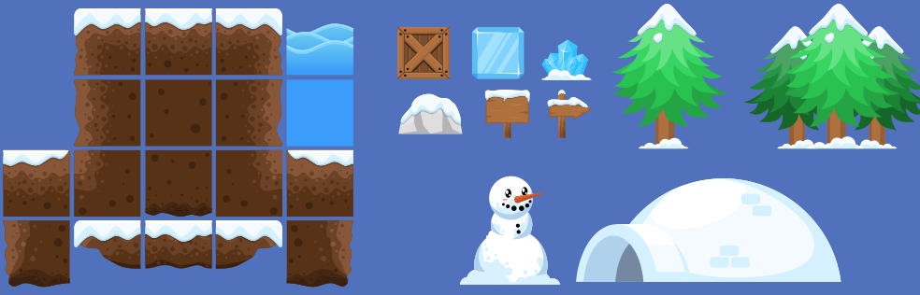  
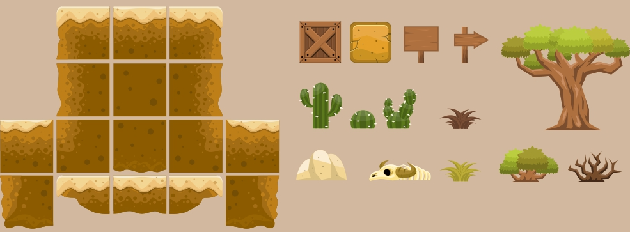  
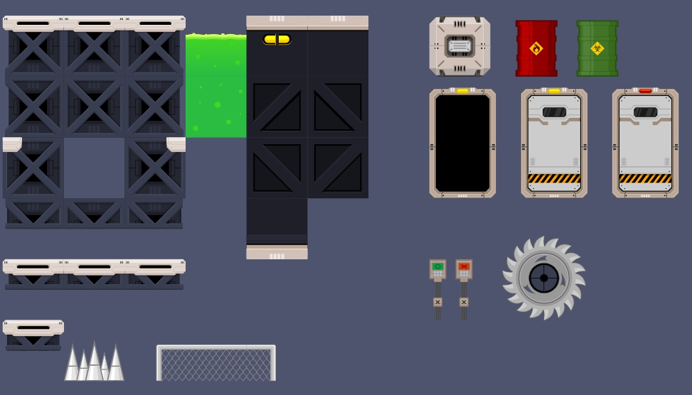

Tile Set Traps (Just a placeholder):  
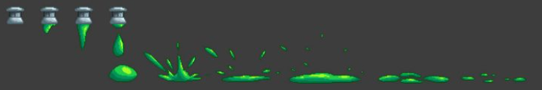  
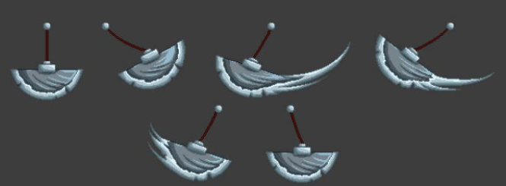  
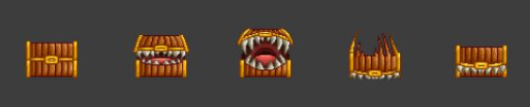

Modes

Single Player mode:  
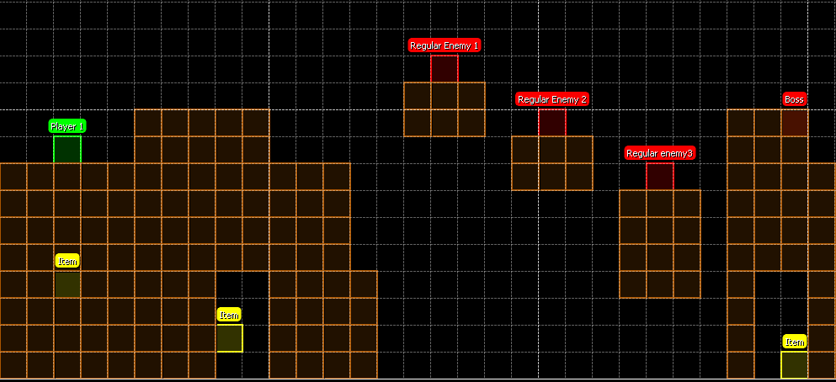

Cooperative mode:  
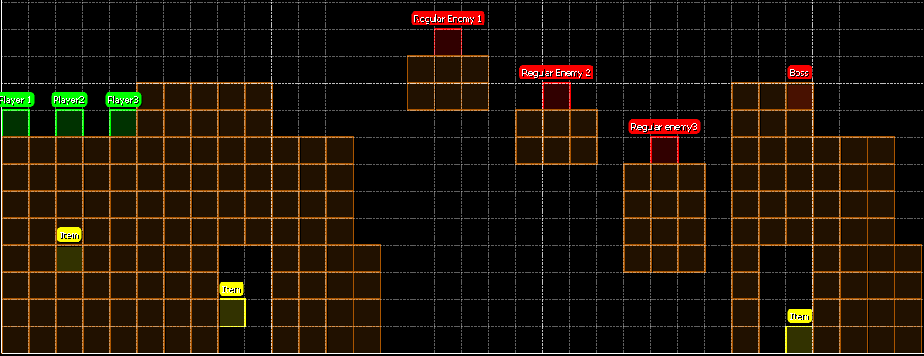

PvP mode:  
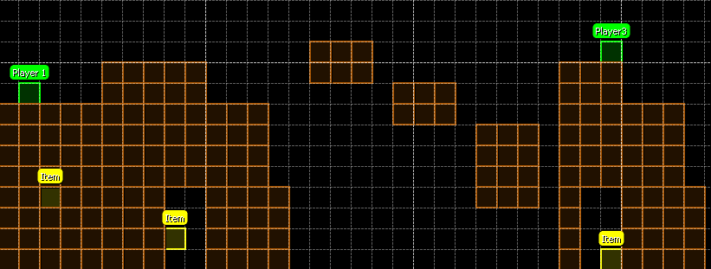

Battle Royale mode:  
